**Test Plan**

Project Name: Fraction Runner

Team Name: Team DBA

Team Members: (we are all involved with the testing process)

* Gregory Shelton gpsc7c@umsl.edu
* Maija Garson mmgzzn@umsl.edu
* Kayla Thurman kethurman@mail.umsl.edu
* Sadaf Shakeel ssmkh@missouri.edu
* James Platt jbpkcd@mail.umsl.edu

Revision History:

04/18/2023 – 1st Draft

04/20/2023 – Revision after group discussion

04/21/2023 – Revision after group discussion

5/4/2023 – Revision to expand testing steps

5/5/2023 – Revision to add new test results

**Section 1: Introduction**

In this game, the object is to see how long you can stay alive.

Upon start, the player is asked to write a number.

The game uses the player’s number to create a repeating decimal that is the ground for the character to run on.

As the character runs, there will be various obstacles the character must avoid or attack.

The character runs on top of the numbers using Jump, Duck, or Attack to stay alive.

When the character collides with an obstacle, the game is over.

The player that stays alive the longest time is the winner.

To encourage replay, players can choose between 3 different characters.

Different number entries will create a different environment for characters to run on.

Players can play against themselves and also others to get the high score on the scoreboard.

The educational purpose of the game is to introduce a mathematical process. The players will learn how it works and functions.

**Section 2: Items to be tested (Database)**

2.1 Provide a successful connection to the Database (DB) – connect with no errors.

Test the time to log in, is it a quick and simple process?

Date clear box tested: 04/12/2023 Result: Success Tester: GS

2.2 Ensure lack of access to DB is reported – only those with access are allowed in.

Try some wrong passwords as several correct ones. Make sure it is consistent when testing.

Error message is given if user doesn’t have access.

Date clear box tested: 04/13/2023 Result: Success Tester: GS

2.3 Ensure user can input digit string and DB can store it in a fraction

There should be validation testing on this step. Error messages if non-digit is entered.

Date clear box tested: 04/13/2023 Result: Success Tester: GS

2.4 The DB keeps track of previous player’s number strings.

The game will show if the string has previously been used.

This will encourage the player to create new, previously unused digit string.

Date clear box tested: 04/13/2023 Result: Success Tester: GS

2.5 Correctly insert a new user with blank points and digits into DB

This step will be testing the sign up functionality. Does the game guide the user to correct mistakes made during sign up process?

Date clear box tested: 04/14/2023 Result: Success Tester: GS

2.6 Users should not be able to have duplicate names. The game should report if a user name is already taken. Make sure the error message is easy to understand and guides user to create a new, unused name.

Date clear box tested: 04/14/2023 Result: Success Tester: GS

2.7 The DB should store user high scores and their number string history.

This should be displayed under the user’s profile in an easy to read table.

Date clear box tested: 04/12/2023 Result: Success Tester: GS

2.8 When deleting a user, verify the correct credentials are entered.

Check that a wrong password does not allow this step to complete.

Users can’t be deleted without their correct password.

Date clear box tested: 04/15/2023 Result: Success Tester: GS

2.9 Test the log in functions. This is a password / user verification test.

Need to ensure correct password acceptance and wrong password is rejected.

Try with CAPS lock on to check case acceptance.

Date clear box tested: 04/16/2023 Result: Success Tester: GS

2.10 Testing to see the scoreboard functionality.

Check the saving feature works and successfully saves.

For example, the highest 100 ranked users, player history, etc.

100 ranked users CB test: 04/19/2023 Result: Success Tester: GS

2.11 Test log out functionality.

Make sure the user can successfully logged out.

Check user’s session to make sure it ends after logging out.

Date tested: 5/7/23 Result: Pass Tester: MG

2.12 Testing for web page navigation.

Need to ensure the session does not break or crash between web pages.

Test this feature on long running sessions.

Date tested: 5/7/23 Result: Pass Tester: MG

2.13 Ensure user can’t access log in page while already logged in.

This test will make sure a user’s session can’t be broken by a new log in.

Try both correct and incorrect log in credentials to see the results.

Date tested: 5/7/23 Result: Pass Tester: MG

2.14 Check HTML and CSS on site displays correct data and visuals while moving between pages. This will be a validity check on the structure of the site.

Need to examine all pages and navigation paths.

Initial CB Test: 04/12/2023 Result: Failure Tester :GS

Reimplementation CB Test: 04/16/2023 Result: Success(of implemented) Tester :GS

**Items to be tested (Gameplay)**

2.15 Verify the character selection screen is working. When player chooses a character, the character image is correct during gameplay. Will be looking for consistency among all of the characters.

Date tested: 5/5/23 Result: Pass Tester: JP

2.16 Testing for data validation from user’s input. The game should restrict the player input for digit string only. And the string should be a 1-9 digit sequence. Try using non-digits and also using 0 and more than 9 digits. Make it a very comprehensive test ensuring validation.

Date tested: 4/2/23 Result: Fail Tester: KT  
Date tested: 4/2/23 Result: Pass Tester: KT  
Date tested: 4/17/23 Result: Pass Tester: KT

Date tested: 5/5/23 Result: Pass Tester: JP

2.17 Test the start of the game begins when player presses start button. Will be verifying the obstacles are not too close to the character at start of the game. Check the game starts quickly and correctly upon pressing the start button.

Date tested: 4/16/23 Result: Fail Tester: KT  
Date tested: 4/17/23 Result: Pass Tester: KT

Date tested: 5/5/23 Result: Pass Tester: JP

2.18 Check the digits on the ground when running. It must display the correct number string entered by the player. Check the correct number successfully repeats on the ground.

Date tested: 4/1/23 Result: Fail Tester: KT  
Date tested: 4/2/23 Result: Pass Tester: KT  
Date tested: 4/17/23 Result: Pass Tester: KT

Date tested: 5/5/23 Result: Pass Tester: JP

2.19 Verify that character performs correct action on pressing the associated button (i.e. character jumps when jump button is pressed, ducks when duck button is pressed, Etc.)  
Do the actions provide enough wiggle room and can be slightly forgiving during gameplay?

Date tested: 4/15/23 Result: Fail Tester: KT  
Date tested: 4/16/23 Result: Pass Tester: KT

Date tested: 5/5/23 Result: Pass Tester: JP

2.20 Test the character sprite animates appropriately as it moves. Check to see if the animations are correct for each action. Make sure animations are smooth and easy to follow.

Date tested: 4/16/23 Result: Fail Tester: KT  
Date tested: 4/19/23 Result: Pass Tester: KT

Date tested: 5/5/23 Result: Pass Tester: JP

2.21 Examine the background and the scrolling effects. Check for gaps between background transitions. The number string should continue to scroll across the bottom of the screen at a constant rate. Test for consistency on this step.

Date tested: 4/1/23 Result: Fail Tester: KT  
Date tested: 4/2/23 Result: Pass Tester: KT  
Date tested: 4/17/23 Result: Pass Tester: KT

Date tested: 5/5/23 Result: Pass Tester: JP

2.22 Test the objects on this step. They should spawn and move across the screen from the right and de-spawn as they leave the screen on the left. It should be a smooth animation as the objects approach. The movement should be consistent and give the player ample time to choose correct action.

Date tested: 4/18/23 Result: Fail Tester: KT  
Date tested: 4/18/23 Result: Pass Tester: KT

Date tested: 5/5/23 Result: Pass Tester: JP

2.23 Test the status of object collisions. When the player collides with an object, it should trigger a Game Over message. The game should then create the lose state and provide the player with next steps. Verify it is very easy for the user to start a new game, log out and check the scoreboard.

Date tested: 5/5/23 Result: Pass Tester: JP

2.24 Test that objects can be destroyed easily when the correct action is executed. When the player collides with a destructible object while character is in the attacking state, the object should be destroyed.

Date tested: 5/5/23 Result: Pass Tester: JP

2.25 Test the scoring functions of the game. The score should increase each time an object leaves the screen on the left side. The game should continue as expected and stops when the player dies. Check to see player can see their final score on the Game Over screen.

Date tested: 5/5/23 Result: Pass Tester: JP

2.26 Test the Game Over function. The game should display options to restart. Make sure it is easy to get a new game going quickly. Make sure the Game Over page does not time out. The player should remain logged in until selecting the log out feature.

Date tested: 5/5/23 Result: Pass Tester: JP

2.27 Verify the spacebar on the Game Over screen allows player to quickly start a new game. . Check to see player can choose a different character and number string. The navigation starting a new game is simple and seamless.

Date tested: 5/5/23 Result: Pass Tester: JP

**Section 3: Test team – Signatures** (Sign off using tester’s initials)

* Gregory Shelton - GS
* Maija Garson - MG
* Kayla Thurman - KT
* Sadaf Shakeel - SS
* James Platt - JP

Appendix: User Manual

**User Manual**

Welcome to Fraction Runner, an educational running game!

In this game, the object is to see how long you can stay alive.

Upon start, the player is asked to write a number.

The game puts player’s number in a fraction as the numerator over the same number of 9s in denominator.

(Example: 443 becomes 443/999)

The division produces a string of repeating decimals which will be displayed as the ground.

(From our earlier example: 443/999 becomes 0.443443443...)

The player runs on top of the numbers using Jump, Duck, or Attack to stay alive.

The player that stays alive the longest time is the winner.

When running, check out the repeating decimals.

On the Home Screen you will see three choices:

Fraction Runner – select when you are ready to begin the game

Introduction Page – click to learn more about the game and its developers

Top 100 Scoreboard – pick this to see who has the high score

Player will log in on the Log in Page:

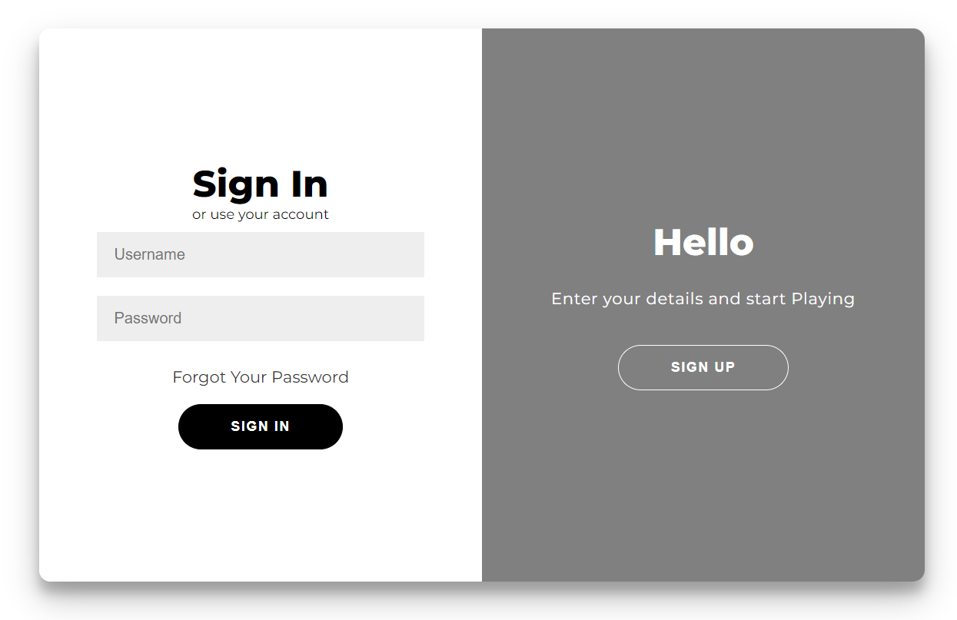

Controls:

Each character can perform three different actions:

*Jump – spacebar or click jump

*Attack – enter or click attack

*Duck – down or click duck

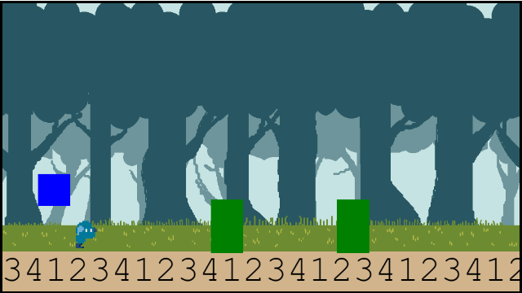

(Screenshot of character ducking)

Gameplay:

At the start, the player is asked to select a character.

There is no skill difference between the characters.

When starting the game, the player must pick a number up to 999,999,999.

After entering the number, the running game begins.

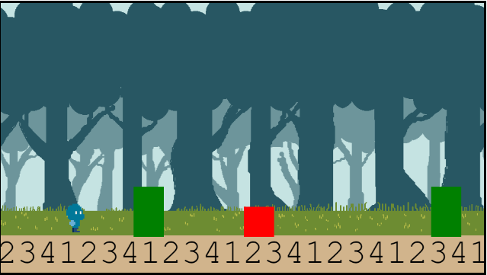

The object of the game is to see how long the player can stay alive.

The timer starts at the beginning of the game.

Once the player has been hit by an object, the game is over.

The time is calculated and added to the Scoreboard.

Fraction Runner Scoreboard

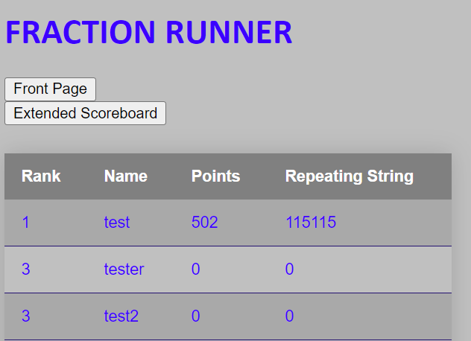

Tips and Tricks:

*There are three different obstacles. Each one can only be defeated by the correct action.

*Use Jump when a hole appears

*Use Duck when a bat is flying

*Use Attack to break a wall

*The runner will speed up as time continues. Stay alert!

We Thank you for playing Fraction Runner.